**Project Summary:**

The primary problem this dataset can address revolves around optimizing personal financial management and identifying opportunities for savings based on an individual's lifestyle, demographics, and spending habits.

This contains detailed information related to individuals' financial situations, demographic characteristics, and spending habits. It includes columns such as Income, Age, Dependents, Occupation, City Tier, and various expense categories like Rent, Groceries, Transport, Eating Out, Entertainment, Utilities, Healthcare, and Education. It also provides insights into financial planning with Desired_Savings_Percentage, Desired_Savings, Disposable_Income, and Potential_Savings across different spending areas.

Specifically, businesses (like financial institutions, personalized budgeting apps, or lifestyle product/service providers) face the challenge of:

* Understanding diverse spending patterns: How do different demographic groups (age, dependents, occupation, city tier) allocate their income across various expenditure categories (rent, groceries, transport, entertainment, healthcare, etc.)?
* Identifying savings potential: Where can individuals realistically cut down on expenses to achieve their desired savings goals, and what are the most impactful areas for potential savings?
* Tailoring financial advice and product offerings: How can financial advice, budgeting tools, or relevant product/service recommendations be personalized to different customer segments based on their income, spending habits, and desired savings?

**How this Dataset is Useful:**

The lifestyle.csv dataset is highly valuable for various stakeholders due to its comprehensive nature of individual financial behavior:

* Financial Institutions and Advisors
* Personalized Financial Planning: Develop customized financial plans and budgeting advice for clients based on their actual income, expenses, and savings goals.
* Product Development: Design new financial products (e.g., specialized savings accounts, loan offerings) that cater to the specific needs and spending patterns of different customer segments.
* Risk Assessment: While not explicitly for credit scoring, understanding spending habits can indirectly inform a more holistic view of financial stability.
* Marketing and Product Companies:
* Targeted Marketing Campaigns: Identify segments of the population that spend more or less on certain categories (e.g., "Eating Out," "Entertainment," "Groceries") to create highly targeted marketing campaigns for relevant products or services.
* Market Research: Understand consumer preferences and spending priorities across different occupations and city tiers.
* Loyalty Programs: Design reward systems or discounts based on spending patterns in specific categories.
* Policy Makers and Urban Planners:
* Cost of Living Analysis: Understand how income and expenses vary across different city tiers, which can inform urban planning and policy decisions related to housing, transportation, and public services.
* Economic Research: Analyze consumer spending trends and their impact on local economies.
* Individual Financial Awareness Tools:
* This data could power personal finance applications, allowing users to benchmark their spending against similar demographic profiles and identify areas for potential savings.

**Insights from this Raw Dataset:**

Based on the initial analysis of the lifestyle.csv dataset, here are some key insights:

* Income Drives Most Spending and Savings: There are very strong positive correlations (all above 0.79, many above 0.9) between Income and most spending categories (Rent, Groceries, Transport, Eating_Out, Entertainment, Utilities, Healthcare, Education, Insurance, Miscellaneous) as well as Desired_Savings and Disposable_Income. This indicates that as income increases, so do expenditures across almost all categories and the capacity for savings.
* Significant Potential for Savings in Core Categories: The Potential_Savings columns reveal substantial opportunities for individuals to save. Groceries and Transport stand out as the top two categories where the largest sum of potential savings across all individuals exists, followed by Utilities, Eating_Out, and Entertainment. This suggests that focusing on these areas could have the biggest impact on overall savings.
* Occupational Spending Differences (Subtle but Present): While the average Income and Disposable_Income are relatively similar across Professional, Retired, Self_Employed, and Student occupations, there are minor variations in average spending. For instance, Professionals and Self_Employed individuals show slightly higher average Rent and Groceries expenses compared to Retired individuals.
* City Tier Impacts Rent and Savings:

Tier_1 cities have significantly higher average Rent expenses compared to Tier_2 and Tier_3 cities.

Conversely, individuals in Tier_3 cities tend to have higher Disposable_Income and Desired_Savings on average, likely due to lower Rent costs, allowing them more financial flexibility

Tier_2 sits in between, with moderate Rent and savings figures.

* Age and Dependents Distribution: The dataset shows a broad distribution for Age (min 18, max 64, mean 41) and Dependents (min 0, max 4, mean 2), indicating a diverse population sample.
* Loan Repayment Variability: While Loan_Repayment has a positive correlation with Income, the minimum value of 0 indicates that a significant portion of individuals might not have active loan repayments, or this field only captures certain types of loans.

These insights provide a strong foundation for developing targeted financial strategies and personalized recommendations.

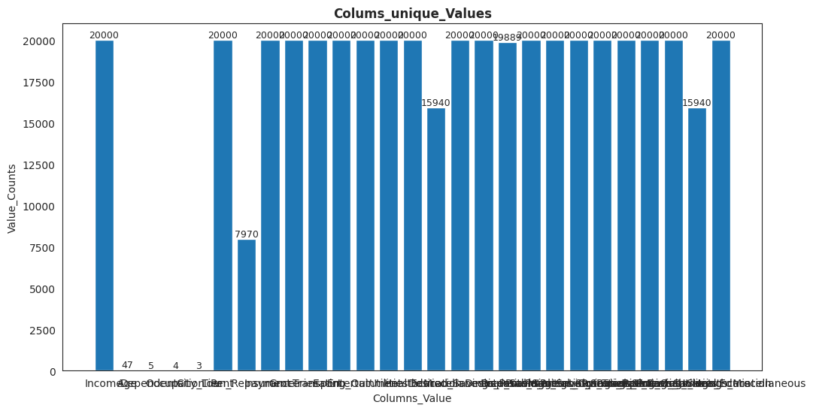

GitHub link:[‘https://github.com/Neethu0207/Market-Analysis/blob/main/EV1.ipynb link’]